SCHEDULE 2 – THE SERVICES

- Service Specifications

Mandatory headings 1 – 4: mandatory but detail for local determination and agreement
Optional headings 5-7: optional to use, detail for local determination and agreement.

Service Specification No. | AWA
Service | SMI Physical Health Checks Service
Commissioner Lead | NHS Gloucestershire ICB
Provider Lead | Gloucestershire Health and Care NHSFT
Period | April 1st 2023 – 31st March 2024
Date of Review | March 2024

1. Population Needs
  - National/local context and evidence base

Background: People with serious mental illness are at some of the greatest risk of poor health and premature mortality, dying on average 20 years earlier than the general population due to preventable physical problems. This is due to a combination of factors including the side effects of anti-psychotic medication, lifestyle, and difficulty in accessing mainstream health services. Estimates suggest there would be up to 12,000 fewer deaths from cardiovascular disease (CVD) each year if people with SMI had the same outcomes as the general population. The reduction in CVD related mortality in the general population is attributed primarily to improvements in diagnosis and treatment.
National policy: In February 2016, NHS England published the Five Year Forward View for Mental Health. Produced by the Mental Health Taskforce it set out the start of a ten-year journey for transformation of mental health services, with the experience of people with mental health problems at the heart of it. Physical health was a key part of that vision. The report recommended that: ‘NHS England should undertake work to define a quantified national reduction in premature mortality among people with severe mental illness, and an operational plan to begin achieving it from 2017/18. NHS England should also lead work to ensure that by 2020/21, 280,000 more people living with severe mental illness have their physical health needs met by increasing early detection and expanding access to evidence-based physical care assessment and intervention.’
Between 2014 and 2016, NHS England worked with staff and patients in four mental health trusts to improve the cardiovascular (CVD) health outcomes and reduce premature mortality in people with serious mental illness. CVD is the biggest cause of premature death in this patient group. The four trusts took different approaches to the problem, considering local priorities and ways of working, but each one involved implementing the Lester screening tool (2014). One of these sites was 2GNHSFT (now GHCNHSFT). 2GNHSFT worked to achieve the 2017/19 National CQUIN; “Improving physical healthcare to reduce premature mortality in people with serious mental illness (SMI)”. This CQUIN built on the developments across England to improve physical health care for people with SMI. The aim was to ensure that all patients with SMI receive annual cardio-metabolic screening assessments and have access to the necessary treatments and interventions, as well as to ensure a stronger emphasis on collaboration and communication between Primary and Secondary Care.
Evidence: The Five Year Forward View for Mental Health [1], NHS England committed to leading work to ensure that by 2020/21, 280,000 people living with severe mental illness (SMI) have their physical health needs met by increasing early detection and expanding access to evidence-based physical care assessment and intervention each year.
In Implementing the Five Year Forward View for Mental Health [2] and the NHS Operational Planning and Contracting Guidance 2017-19 [3], NHS England stated that “CCGs should offer NICE-recommended screening and access to physical care interventions to cover 30% of the population with SMI on the GP register in 2017/18, moving to 60% population from the following year”. This commitment was reiterated in the March 2017 publication of the Next Steps on the NHS Five Year Forward View [4]. Further, the guidance on Refreshing NHS Plans for 2018/19 published in February 2018 highlighted the same requirement to deliver annual physical health checks and interventions, in line with this guidance, to at least 280,000 with SMI in 18/19.
To support planning, in line with Refreshing NHS Plans for 2018/19, CCGs were provided with figures on the numbers of people on GP practice SMI Registers. This will enable development of a robust quarterly trajectory for each CCG throughout 2018/19 and beyond.
From April 2017, transformation funds entered all CCGs’ baselines to support increasing the delivery of required physical health screening, improving access to physical health interventions, beyond the currently incentivised assessments within the Quality and Outcomes Framework (QOF).
CCG/ICBs have a delegated responsibility to improve physical healthcare for people with SMI in line with their legislative duties for addressing equalities and health inequalities. In accordance with the Public Sector Equality Duty, section 149 (1) of the Equality Act 2010 [5] and the Health and Social Care 2012 [6], CCGs alongside other bodies have duties regarding:
• eliminating unlawful discrimination under the Equality Act 2010.
• advancing equality of opportunity.
• fostering good relations.
• reducing health inequalities in access to health and health outcomes; and
• improving services and developing more integrated services.
CCG/ICBs responsibilities to improve the quality of physical healthcare for people with SMI are one important part of a broader commitment across STPs to reduce premature mortality and address health inequalities.

2. Outcomes
2.1 NHS Outcomes Framework Domains & Indicators

Domain 1 | Preventing people from dying prematurely
Domain 2 | Enhancing quality of life for people with long-term conditions
Domain 3 | Helping people to recover from episodes of ill-health or following injury
Domain 4 | Ensuring people have a positive experience of care
Domain 5 | Treating and caring for people in safe environment and protecting them from avoidable harm

2.2 Local defined outcomes
Ensure service provision includes:
1. Completion of recommended physical health assessments,
2. Support follow-up: delivery of or referral to appropriate NICE concordant interventions
3. Support follow-up: delivery of or referral to appropriate personalised care planning, engagement and psychosocial support.

3. Scope
3.1 Aims and objectives of service
To provide a comprehensive and systematic annual health check and cardiovascular risk assessment for those patients who are currently on the Severe and Enduring Mental Illness register (SMI) and support Primary care to build upon the existing QOF Criteria for Mental Health (MH).
3.2 Service description/care pathway
A) Primary care teams are responsible for carrying out annual physical health assessments and follow-up care for:
1. patients with SMI who are not in contact with secondary mental health services, including both:
a. those whose care has always been solely in Primary Care, and
b. those who have been discharged from secondary care back to Primary Care; and
2. patients with SMI who have been in contact with secondary care mental health teams (with shared care arrangements in place) for more than 12 months and / or whose condition has stabilised.

B) Secondary care teams are responsible for carrying out annual physical health assessments and follow-up care for:
1. patients with SMI under care of a mental health team for less than 12 months and/or whose condition has not yet stabilised
2. inpatients

Delivering a comprehensive physical healthcare approach for people with SMI:
This service will support and enable delivery of A within Primary Care and B in Secondary Care through dedicated provision of HCA/nursing input to PCN’s/GP Clinics and GHC Community teams.

Accessible, comprehensive, and evidence-based physical healthcare includes three key elements:
1. Completion of recommended physical health assessments:
All adults on the SMI register should receive the full list of recommended physical health assessments as part of a routine check at least annually (NICE clinical guidelines CG185 and CG178). Assessments should be undertaken more frequently as required:
a) for the purposes of monitoring specific antipsychotics or other medications (local policies and procedures may apply according to local Drug and Therapeutic Monitoring Committee); or
b) Where a significant physical illness or risk of a physical illness has already been identified (NICE clinical guideline CG120).

Figure 1 (below) provides a summary of the recommended physical health assessments for people living with SMI, which has been developed with the input of a clinical reference group. A comprehensive physical health check includes several assessments not currently featured within the Quality and Outcomes Framework for Primary Care. It builds upon the Lester Positive Cardio-metabolic Health Resource [7] for use in secondary care and the NHS Health Check [8] in Primary Care.

The recommended assessments include cardiovascular risk scoring; however, it is important to note that existing cardiovascular disease risk scores can underestimate risk in those with psychosis. The recommended physical health assessment aligns to the NHS Health Check, but unlike the NHS Health Check it should be offered annually to all age groups (rather than every 4 years to people aged 40-74). In addition to the NHS Health Check assessments the physical health assessment for people with SMI should include relevant national screening and immunisation programmes, as recommended by Public Health England (PHE), medicines reconciliation, and additional general physical health enquiry into sexual health, oral health and substance misuse.
All physical health assessment results and agreed actions are to be entered into the patient electronic record.

2. Follow-up: delivery of or referral to appropriate NICE concordant interventions: “don’t just screen, intervene”. Appropriate evidence-based physical care interventions should be provided for all physical health risk(s) or conditions identified during the assessment including:
- For alcohol and illicit/non-prescribed drug use: follow guidance on co-occurring substance misuse and SMI (NICE Clinical Guideline CG120).
- For Obesity prevention [NICE CG43]
- For Physical activity: brief advice for adults in primary care [NICE PH44]
- For Hypertension in adults: diagnosis and management [NICE CG127],
- For Type 2 diabetes prevention and treatment NICE PH38, NICE NG28, and [NICE NG28]
- For Type 1 diabetes diagnosis and management [NICE NG17, NG18 and NG19]
- For Lipid modification [NICE CG181]
- For current smokers: facilitate smoking cessation through pharmacotherapies, intensive behavioural support, and methods such as carbon monoxide monitoring (NICE Public Health Guideline PH 48).
- Access to secondary physical health interventions should be enabled through:
  - clear and effective communications (such as texts and phone calls, not just paper letters) with service users and carers about the required follow-up
  - clear and robust referral systems to specialist physical healthcare

3. Follow-up: personalised care planning, engagement, and psychosocial support
Personalised care planning is necessary to ensure people with SMI are supported to make the lifestyle and behaviour changes needed to achieve and sustain improvements in their physical health. Personalised care planning should address the full needs of the service user, taking steps to combat loneliness, isolation and promoting wider engagement in self-care, exercise, healthy eating, and lifestyle. ‘Social prescribing’ supports personalised care planning by working across health and social care organisations, voluntary sector, community, and faith groups. Additionally, links will be made to Healthy living options and Active Gloucestershire to ensure a holistic approach which addresses self-care and self-management as part of the over-arching approach to enhancing the physical health of the SMI cohort and addressing the current health inequalities, life experiences and life expectancy.
Other Service Requirements

Staff Training and Supervision – All relevant staff must have a current Basic Life Support certificate. Practices are responsible for equipment that must be available and supporting staff are conversant with, supported by current resuscitation protocol.

Coding – Supporting Practices to use the relevant Read Code(s), further information is available at Appendix 1 (page 8) when recording activity in the patient record.

Reporting – Supporting Practices to complete and submit the annual reporting template provided by GICB and any additional information (e.g., GICB PCCAG audit).
Information Governance - Patients will need to be notified that their anonymised data, that is whether the physical health checks have been done or not (not the results of those checks), will form part of locally and nationally reported PHSMI data.
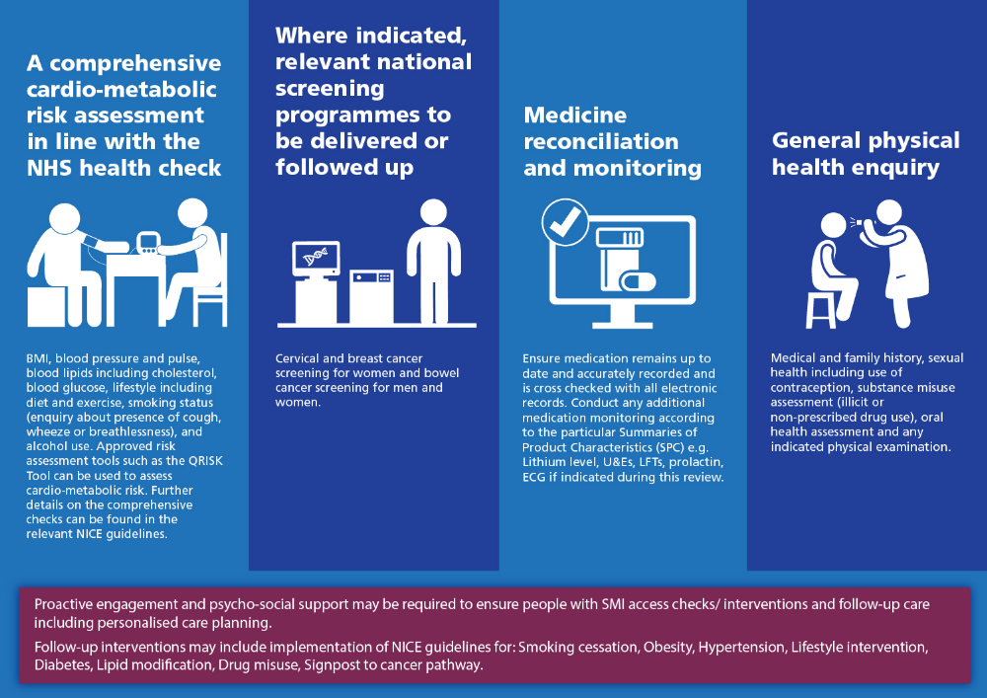
Figure 1: The recommended physical health assessments for people on the SMI register

3.3 Population covered
Adults (18 years of age and over) registered with a Gloucestershire GP Practice.

3.4 Any acceptance and exclusion criteria and thresholds
The SMI register refers to all individuals who have received a diagnosis of schizophrenia or bipolar affective disorder, or who have experienced an episode of non-organic psychosis.

3.5 Interdependence with other services/providers
Close links and 2-way communication required with PCN/GP Clinics, GHC community and inpatient services to ensure case registers are up to date and consistent across providers.
Additionally, links will be made to Healthy Living options and Active Gloucestershire to ensure a holistic approach which addresses self-care and self-management as part of the over-arching approach to enhancing the physical health of the SMI cohort and addressing the current health inequalities, life experiences and life expectancy.
Links with social prescribing hubs to ensure a holistic approach to wellbeing.
Links to developing PCN / Community Transformation services.
Appropriate onward referral to specialist services where physical health concerns are identified.

4. Applicable Service Standards
4.1 Applicable national standards (e.g. NICE)
NICE CG185, CG178, CG120, CG43, CG127, CG181
NICE PH44, PH38, PH48
NICE NG28, NG17, NG18 and NG19

4.2 Applicable standards set out in Guidance and/or issued by a competent body (e.g. Royal Colleges)
Naylor C, Das P, Shilpa R, Honeyman M, Thompson J, Gilburt H. Bringing together physical and mental health: a new frontier for integrated care. London: The King’s Fund; 2016. [Available at: https://www.kingsfund.org.uk/publications/physical-and-mental-health]

4.3 Applicable local standards
Ensure service provision includes:
1. Completion of recommended physical health assessments,
2. Support follow-up: delivery of or referral to appropriate NICE concordant interventions
3. Support follow-up: delivery of or referral to appropriate personalised care planning, engagement, and psychosocial support.

5. Applicable quality requirements and CQUIN goals
  - Applicable Quality Requirements (See Schedule 4 Parts [A-D])
Quarterly reporting: This health check must include all the following elements
1. a measurement of weight (BMI or BMI + Waist circumference)
2. a blood pressure and pulse check
3. a blood lipid including cholesterol test and /or QRISK2
4. a blood glucose test or Haemoglobin (Hba1C)
5. an assessment of alcohol consumption
6. an assessment of smoking status
For this indicator a person is counted as having had a comprehensive physical health assessment if they have received these entire component parts listed above in the last 12 months.

In line with NHS England guidance document Improving physical healthcare for people living with severe mental illness in primary care, the following elements should also be provided for people with SMI as part of a comprehensive health check in line with clinical evidence and consensus.
7. an assessment of nutritional status, diet and level of physical activity
8. an assessment of use of illicit substance / non prescribed drugs
9. support access to relevant national screenings
10. medicines reconciliation and review
11. general physical health enquiry into sexual health and oral health
12. indicated follow-up interventions
NB. For Primary Care QOF purposes regarding ‘in remission’ cases: do not count those in remission. Patients are counted as 'in remission' and therefore exempt if they have had no medication for 5 years and no mental health admissions or contact with MHT for 5 years.

  - Applicable CQUIN goals (See Schedule 4 Part [E])
N/A

6. Location of Provider Premises
The Provider’s Premises are located at:
GHC Community services
GP Practice locations throughout Gloucestershire

References:

1. NHS England. The Five Year Forward View for Mental Health – report from the Mental Health Taskforce. Leeds: NHS England Mental Health Taskforce; 2016. [Available at: https://www.england.nhs.uk/wp-content/.../Mental-Health-Taskforce-FYFV-final.pdf]
2. NHS England. Implementing the Five Year Forward View for Mental Health. Leeds: NHS England; 2016. [Available at: https://www.england.nhs.uk/wp-content/uploads/2016/07/fyfv-mh.pdf]
3. NHS England and NHS Improvement. NHS Operational Planning and Contracting Guidance 2017-2019. Leeds: NHS England; 2016. [Available at: https://www.england.nhs.uk/wp-content/uploads/2016/09/NHS-operational-planning-guidance-201617-201819.pdf]
4. NHS England. Next steps on the NHS Five Year Forward View. Leeds: NHS England; 2017. [Available at: https://www.england.nhs.uk/wp-content/uploads/2017/03/NEXT-STEPS-ON-THE-NHS-FIVE-YEAR-FORWARD-VIEW.pdf]

5. Great Britain. The Equality Act 2010. London: Her Majesty’s Stationery Office; 2010. [Available at: http://www.legislation.gov.uk/ukpga/2010/15/contents]
6. Great Britain. Health and Social Care Act 2012. London: Her Majesty’s Stationery Office; 2012. [Available at: http://www.legislation.gov.uk/ukpga/2012/7/contents/enacted]

7. Shiers DE, Rafi I, Cooper SJ, Holt RIG. (2014 update, with acknowledgement to the late Helen Lester for her contribution to the original 2012 version). Positive Cardiometabolic Health Resource: an intervention framework for patients with psychosis and schizophrenia. London: Royal College of Psychiatrists; 2014. [Available at: https://www.rcpsych.ac.uk/pdf/Lester%20update%20June%202014%20FINAL.pdf]

8. NHS Choices. NHS Health Check. n.d. [Available at: http://www.nhs.uk/Conditions/nhs-health-check/Pages/NHS-Health-Check.aspx]

Appendix 1 – Coding for SMI Health Checks & Templates
For Data Recording: each GP clinical system supplier has provided a template/guideline to use during these consultations.
These templates will allow recording of the 6 elements making up the physical health check and the subsequent interventions relevant to the patient. These are:
- a measurement of weight (BMI or BMI + waist circumference).
- a blood pressure and pulse check.
- a blood lipid including cholesterol test (cholesterol measurement or QRISK® measurement);
- a blood glucose test (blood glucose or HbA1c measurement);
- an assessment of alcohol consumption.
- an assessment of smoking status.
Interventions, if relevant to the patient:
- Nutritional status or diet.
- Level of physical activity.
- Illicit substance/non-prescribed drug use.
- Medicines reconciliation or review.
- Referral to weight management services.
- Anti-hypertensive medication.
- Referral to NHS Diabetes Prevention Programme.
- Intensive structured lifestyle education programme.
- Oral diabetes medication or insulin
- Alcohol health education
- Referral to alcohol cessation service
- Smoking cessation advice or referral to smoking cessation services
- Smoking cessation drug therapy or nicotine replacement therapy (NRT)
- Under the care of substance misuse services
- Statins
- Cervical cancer screening
- Breast cancer screening
- Bowel cancer screening
For Data Reporting (audit): PCCAG will ensure the codes contained within these supplier-based templates are all included within the reporting process for local audit and subsequent data submission to NHSE.

Appendix 2 – Primary Care Reporting - See supporting information on G-Care

