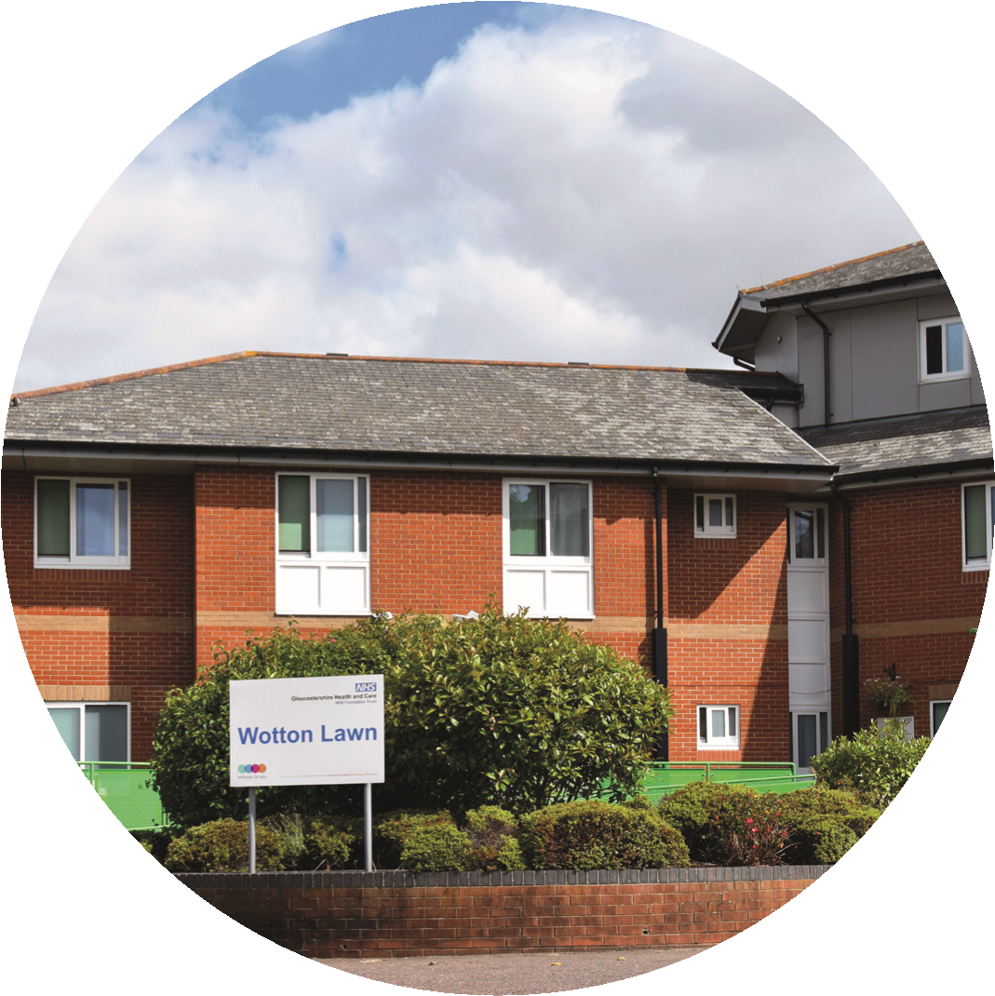
Wotton Lawn Hospital
ECT Information for patients and Carers

What is ECT and why is it used?
ECT is an effective treatment for some types of severe mental illness. It is usually considered when other treatment options, such as psychotherapy or medication, have not been successful or when someone is very unwell and needs urgent treatment.
ECT is given as a course of treatments, typically twice a week for 3–8 weeks. If you have ECT, it will take place under general anaesthetic. This means that you will be asleep while it happens. While you are asleep, your brain will be stimulated with short electric pulses.
This causes a fit which lasts for less than two minutes. As well as an anaesthetic, you will be given a muscle relaxant which reduces how much your body moves during the fit.

If you would like to know more, please speak to the ward staff or for more information.

Giving consent to having ECT
Like any significant treatment in medicine or surgery, you will be asked to give consent, or permission for the ECT to be done. The doctor should explain (in a way that you can understand) their reasons for suggesting ECT, the possible benefits and any side-effects. If you decide to go ahead, you then sign a consent form. It is a record that ECT has been explained to you, that you understand what is going to happen, and that you give your consent to it. However, you can withdraw your consent at any point, even before the first treatment.
Preparing for ECT
- In the days before your course of ECT is started, your doctor will arrange for some tests to make sure it is safe for you to have a general anesthetic. These may include a record of your heartbeat (ECG) and blood tests.
- You must not eat or drink anything for at least 6 hours before ECT, although you may be allowed to drink sips of water up to 2 hours beforehand. This is so you can have the anesthetic safely.
- If you would usually take medication during this time, ask the ECT team for advice on whether you should still do this.

What may I experience when visiting?
On the day you have ECT
- You go to the ECT suite.
- If you are a day patient, you will go there with the adult you have chosen to come with you.
- If you are an inpatient, you will be taken there by ECT staff.
- You will be met by a member of the ECT staff, who will do routine physical checks (if they have not already been done)
- When you are ready, the ECT staff will take you into the treatment area.
- The staff will connect monitoring equipment to measure your heart rate, blood pressure, oxygen levels and brain waves.
- You will be given oxygen to breathe through a mask. The anesthetist will give you an anaesthetic through an injection into the back of your hand
- As an out patient you will be given an appointment time you must be accompanied by a responsible adult. This is the person who is agreeing to remain with you for 24hrs following ECT

As you have been made aware ECT involves receiving a general Anaesthetic, therefore for 48 hours after treatment you must not: -
- Drink alcohol
- Take non-prescribed drugs, except simple pain killers
- And take medical advice before driving, operating machinery, Or signing legal documentation
- Take sole charge of Children

If you have any queries or require support (e.g. access to an interpreter, how to change the appointment time or have difficulty in getting there ,then please notify the ECT lead nurse ( Monday and Thursday, contact : 013004214761) . She/he will confirm if your next ECT treatment needs rescheduling after consultation with the anesthetist.

The ECT Suite

The ECT suite is open 08.00hrs –midday TUESDAY and FRIDAY

The ECT suite is located on the ground floor of Wotton lawn hospital, Horton road Gloucester GL13WL Telephone number (01300) 4214762 ( Tuesday and Friday) / (01300)4214761 ( Monday and Thursday)

The ECT clinic ( Ellis suite) consists of, an interview room, seated Recovery with a kitchenette, treatment suite, lying recovery, and a washroom.

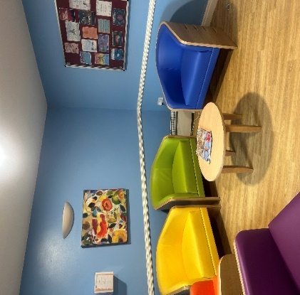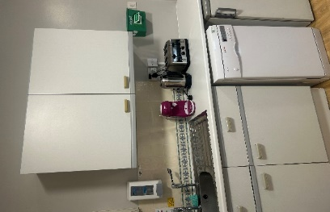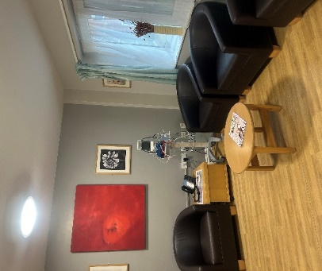
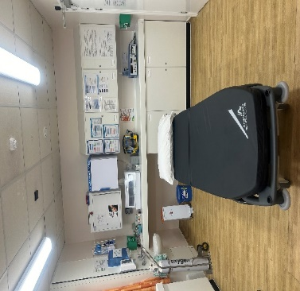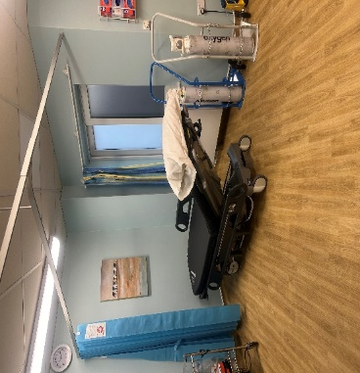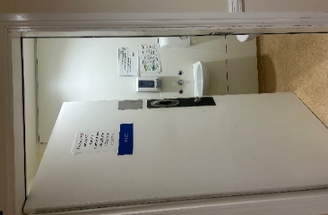

safekeeping of valuables;
We are actively discouraged from bringing valuables, cash, and other non-essential items property with the patients. It is responsible of the accompany person/staff to take care of patient’s valuables.

Directions and Parking
There is a small carpark at Wotton Lawn for visitors however these spaces are limited. We would suggest using pay and display road parking around the area or the parking available at Gloucester Royal Hospital, should the carpark be full.

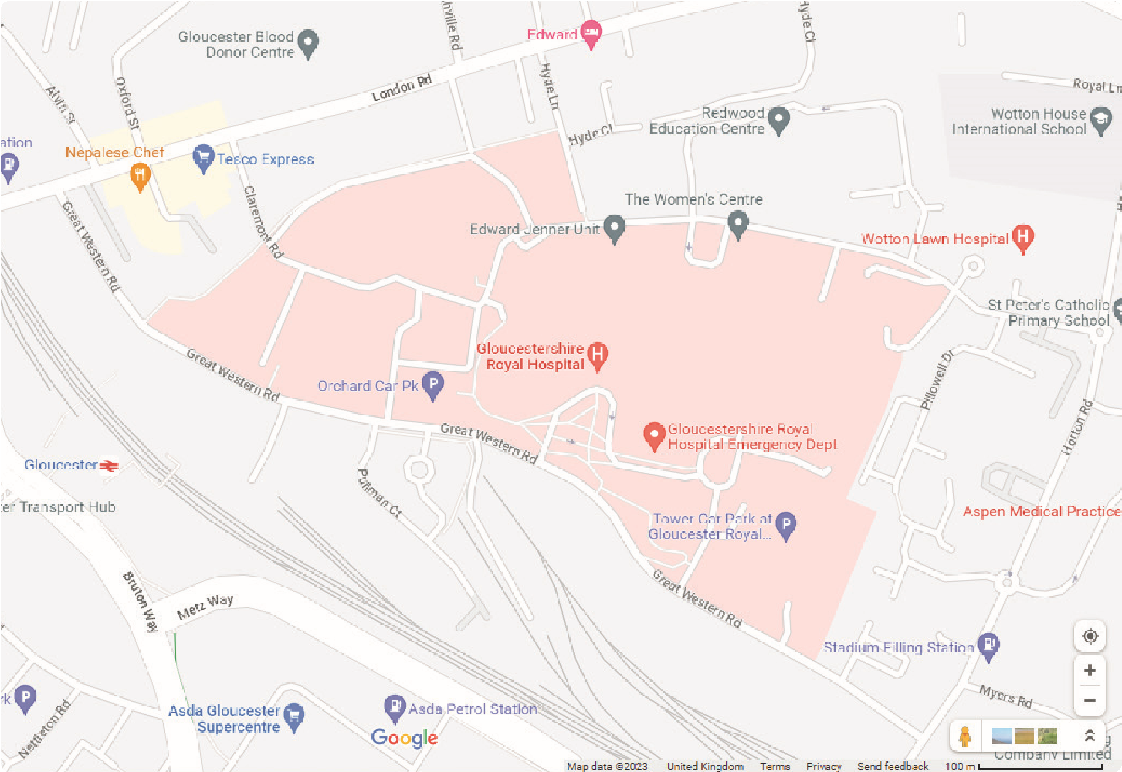

Feedback
The trust welcomes feedback both from service users and their carers via the Friends and Family test.

www.ghc.nhs.uk/get-in-touch/give-us-views/

Your experience
Your views are important to us.
You can contact us between 9am and 5pm, Monday to Friday. 0300 421 8313 (answerphone available outside office hours) experience@ghc.nhs.uk www.ghc.nhs.uk/get-in-touch/give-us-views
Patient and Carer Experience Team
Gloucestershire Health and Care NHS Foundation Trust
Edward Jenner Court
1010 Pioneer Avenue
Gloucester Business Park
Brockworth
Gloucester
GL3 4AW
For general enquiries or if you would like further information, additional copies or would like to receive this leaflet in another language, large print or on audio format, please contact the Trust Communications Team at the above address.
This leaflet can also be provided in braille, audio format, PDF, large print, easy read and other languages on request.
0300 421 8100 ghc.comms@ghc.nhs.uk

