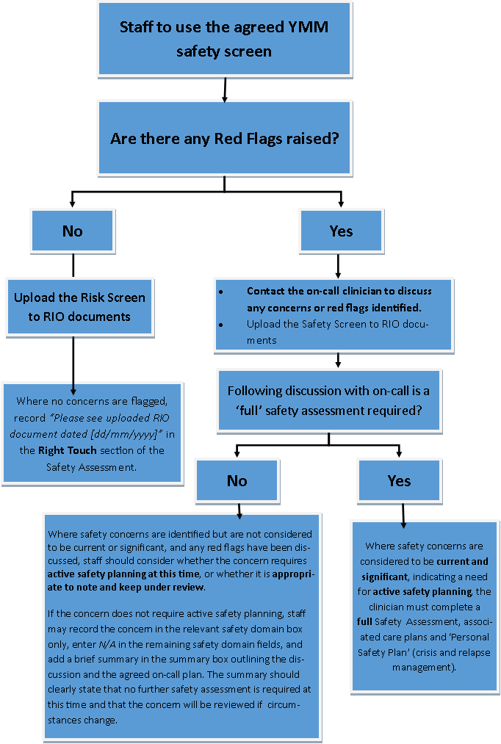
YMM safety Assessment process (Draft 1)
See Diagram 2.
See Diagram 1.

Diagram 1.
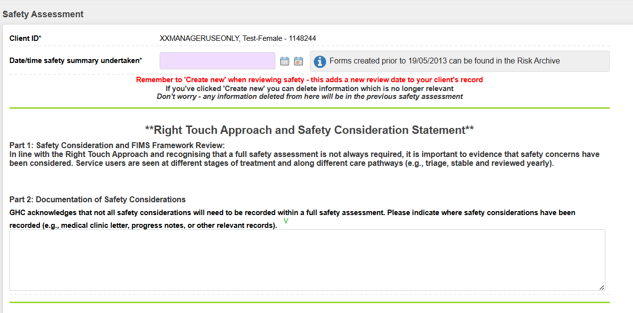
Complete this section at top of safety assessment form once YMM screening has been completed and NO red flags have been raised
Please see YMM safety screening uploaded to RIO documents dated 20/12/2025
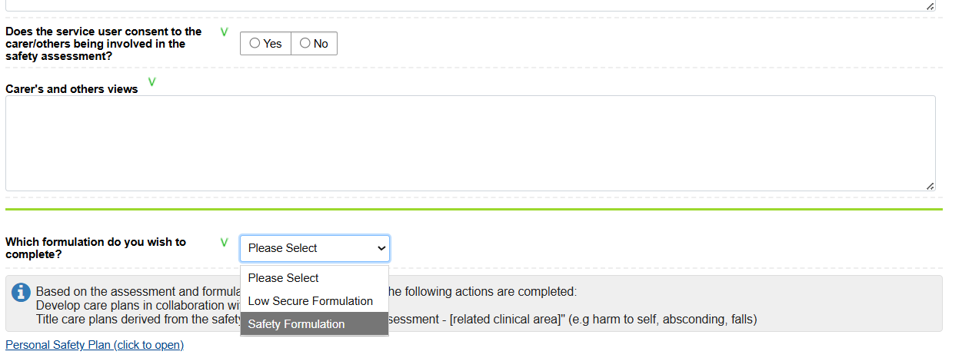
Diagram 2.

Select ‘Safety Formulation’ to open the 5P formulation section

Provide quick summary of discussion with on call clinician
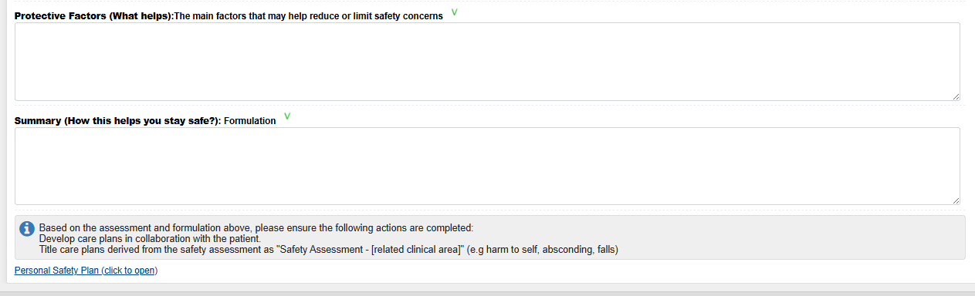
Jamie (aged 6) talked about an incident around six months ago when he hurt his head by banging it on the floor. He explained this happened when he was feeling very angry and felt that no one was listening to him. This was a one-off incident and has not happened again. Jamie said he would not do this again as it hurt and did not help him feel better. This was discussed with the on-call clinician and no further safety assessment is needed at present. This will be reviewed if anything changes or if new concerns arise.

